

**Step - 1 : Problem Statement**

**07_Rising Temperature**

Write a solution to find all dates' Id with higher temperatures compared to its previous dates (yesterday).

Return the result table in any order.

**Difficult Level :** EASY

**DataFrame:**

**# Define the schema for the "Weather" table**

**weather_schema = StructType([**

**StructField("id", IntegerType(), True),**

**StructField("recordDate", StringType(), True),**

**StructField("temperature", IntegerType(), True)**

**])**

**# Define data for the "Weather" table**

**weather_data = [**

**(1, '2015-01-01', 10),**

**(2, '2015-01-02', 25),**

**(3, '2015-01-03', 20),**

**(4, '2015-01-04', 30)**

**]**

**Step - 2 : Identifying The Input Data And Expected Output**

**INPUT**

|  |  |  |
| --- | --- | --- |
| **INPUT** | | |
| **ID** | **RECORDDATE** | **TEMPERATURE** |
| **1** | **2015-01-01** | **10** |
| **2** | **2015-01-02** | **25** |
| **3** | **2015-01-03** | **20** |
| **4** | **2015-01-04** | **30** |

**OUTPUT**

|  |
| --- |
| **OUTPUT** |
| **ID** |
| **2** |
| **4** |

**Step - 3 : Writing the pyspark code to solve the problem**

**# Creating Spark Session**

**from** pyspark**.**sql **import** SparkSession**,**Window

**from** pyspark**.**sql**.**types **import** StructType**,**StructField**,**IntegerType**,**StringType

**from** pyspark**.**sql**.**functions **import** lag**,** col

**#creating spark session**

**spark = SparkSession. \**

**builder. \**

**config('spark.shuffle.useOldFetchProtocol', 'true'). \**

**config('spark.ui.port','0'). \**

**config("spark.sql.warehouse.dir", "/user/itv008042/warehouse"). \**

**enableHiveSupport(). \**

**master('yarn'). \**

**getOrCreate()**

**# Define the schema for the "Weather" table**

**weather_schema = StructType([**

**StructField("id", IntegerType(), True),**

**StructField("recordDate", StringType(), True),**

**StructField("temperature", IntegerType(), True)**

**])**

**# Define data for the "Weather" table**

**weather_data = [**

**(1, '2015-01-01', 10),**

**(2, '2015-01-02', 25),**

**(3, '2015-01-03', 20),**

**(4, '2015-01-04', 30)**

**]**

**# Create a PySpark DataFrame**

**temp_df=spark.createDataFrame(weather_data,weather_schema)**

**temp_df.show()**

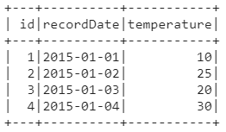

**lag_df=temp_df.withColumn("prev_day",lag(temp_df.temperature).over(Window.orderBy(temp_df.recordDate)))**

**lag_df.show()**

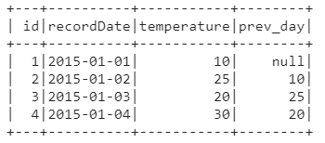

**lag_df.filter(lag_df["temperature"] > lag_df["prev_day"] ).select("id").show()**



